Computer Engineering Department - ITU
CE101L: Object Oriented Programming Lab

Course Instructor: Usama Bin Shakeel | Dated: 15/06/2022
Teaching Assistant: Aqsa Khalid | Semester: Spring 2022
Lab Engineer: Nadir Abbas | Batch: BSCE2021

Lab 14A. Problem Based Learning in Java CFP

Name | Roll number | Report  (out of 100) | Scaled to 10 | Total  (out of 10)
Muhammad Abubakar Saif | BSCE21017

Checked on: ____________________________

Signature: ____________________________

Objective
The objective of this lab is to observe the basic knowledge of programming classes in C++.

Equipment and Component
Component Description | Value | Quantity
Computer | Available in lab | 1

Conduct of Lab
- Students are required to perform this experiment individually.
- In case the lab experiment is not understood, the students are advised to seek help from the course instructor, lab engineers, assigned teaching assistants (TA) and lab attendants.

Theory and Background
Java is a high-level, class-based, object-oriented programming language that is designed to have as few implementation dependencies as possible. Java is a popular programming language. Java is used to develop mobile apps, web apps, desktop apps, games and much more.

Lab Task

Task A: [Marks: 20]

Write a program to find the factorial of a number using loop & recursion in java.

package com.example.main; //if you are running it on ONLINE COMPILER, please REMOVE this line
import java.util.Objects; //imports the class Objects (Use in the program to check that given objects are equal or not)
import java.util.Scanner; //imports the class Scanner (Use in the program for input & output stream)

public class Main {

//Factorial of a number using Recursion:

static int factorial(int num) { //definition of factorial function (recursion)
if (num == 1) { //terminating condition
return 1;
}
return num * factorial(num - 1); //recursive function call
}

//Factorial of a number using Loop:

static int factorialLoop(int num) { //definition of factorial function (through loop)
int mul = 1;
for (int i = 0; i <= num; i++) { //loop control statement
mul = num * mul; //multiply the number with the products of previous number until iteration will become equal to user-given number
num--; //decrement in "num"
}
return mul; //returns the "mul" to the MAIN Function
}

//Main Function:

public static void main(String[] args) { //MAIN FUNCTION / DRIVER CODE
String rep; //declares the string type variable
Scanner obj = new Scanner(System.in); //declares the instance for Scanner class for input stream
int choice; //declares the string type variable
do {
System.out.println("1. Factorial through Recursion"); //prints the given statement
System.out.println("2. Factorial through Loop"); //prints the given statement
System.out.println("Please Enter Your Choice: "); //prints the given statement
choice = obj.nextInt();
switch (choice) { //switch the cases based upon user's selection
case 1:
System.out.println("Enter the value for you want to calculate Factorial: "); //prints the given statement
int num = obj.nextInt(); //takes input from user
int fact = factorial(num); //calls the function to calculate factorial
System.out.print("Your Required Factorial is: "); //prints the given statement
System.out.println(fact); //prints the factorial of the given number
break; //breaks the case
case 2:
System.out.println("Enter the value for you want to calculate Factorial: "); //prints the given statement
int num1 = obj.nextInt(); //takes input from user
int fact1 = factorialLoop(num1); //calls the function to calculate factorial
System.out.print("Your Required Factorial is: "); //prints the given statement
System.out.println(fact1); //prints the factorial of the given number
break; //breaks the case
}
System.out.print("Do you want to use this program again? (Y/N): "); //prints the given statement
rep = obj.next(); //takes input from user
} while (Objects.equals(rep, "Y") || Objects.equals(rep, "y") || Objects.equals(rep, "yes") || Objects.equals(rep, "Yes") || Objects.equals(rep, "YES") || Objects.equals(rep, "yeS"));
}
}

Output:
Factorial through Recursion:
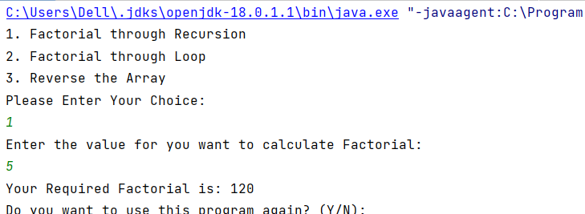
Factorial through Loop:
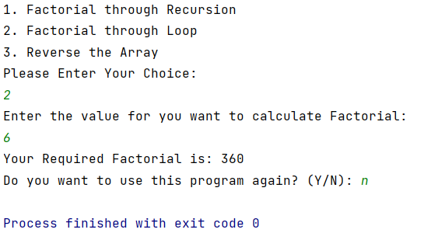

Task B: [Marks: 20]

Write a program to reverse the elements of the array in java.
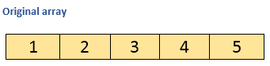
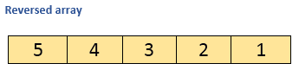
package com.example.main; //if you are running it on ONLINE COMPILER, please REMOVE this line
import java.util.Arrays; //imports the class Array
import java.util.Objects; //imports the class Objects (Use in the program to check that given objects are equal or not)
import java.util.Scanner; //imports the class Scanner (Use in the program for input & output stream)
public class Main {
public static void main(String[] args) { //MAIN FUNCTION / DRIVER CODE
String rep; //declares the string type variable
Scanner obj = new Scanner(System.in); //declares the instance for Scanner class for input stream
int choice; //declares the string type variable
do {
int[] array; //declares array of int type
int[] temp; //declares array of int type
System.out.println("Enter the size of the Array: "); //prints the given statement
int size = obj.nextInt(); //takes input from user
array = new int[size]; //initialize the size of the array
temp = new int[size]; //initialize the size of the temp
for (int i = 0; i < size; i++) { //loop control statement
System.out.print("Element " + (i + 1) + ": "); //prints the (user-friendly) element number of the array
array[i] = obj.nextInt(); //takes input from user
temp[((size - 1) - i)] = array[i]; //saves the array in reverse order in "temp" array
}
System.out.println("Array Before Reversing: " + Arrays.toString(array)); //prints the array elements in the line
System.arraycopy(temp, 0, array, 0, size); //copy the arrays
System.out.println("Array After Reversing: " + Arrays.toString(array)); //prints the array elements in the line
System.out.print("Do you want to use this program again? (Y/N): "); //prints the given statement
rep = obj.next(); //takes input from user
} while (Objects.equals(rep, "Y") || Objects.equals(rep, "y") || Objects.equals(rep, "yes") || Objects.equals(rep, "Yes") || Objects.equals(rep, "YES") || Objects.equals(rep, "yeS"));
}
}

Output:

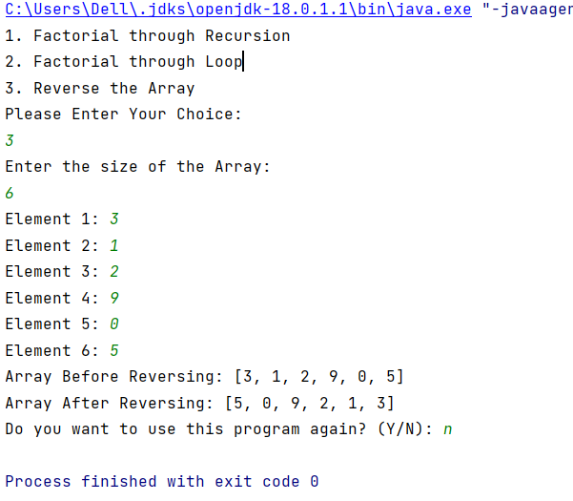

Assessment Rubric for Lab
Method for assessment:

Lab reports and instructor observation during lab sessions. Outcome assessed:
a. Ability to conduct experiments, as well as to analyze and interpret data (P) b. Ability to function on multi-disciplinary teams (A)
c. Ability to use the techniques, skills, and modern engineering tools necessary for engineering practice (P)
Performance metric | Task | CLO | Description | Max marks | Exceeds expectation | Meets expectation | Does not meet expectation | Obtained marks
1. Realization of experiment (a) | 1 | 1 | Functionality | 40 | Executes without errors excellent user prompts, good use of symbols, spacing in output. Through testing has been completed (35-40) | Executes without errors, user prompts are understandable, minimum use of symbols or spacing in output. Some testing has been completed (20-34) | Does not execute due to syntax errors, runtime errors, user prompts are misleading or non-existent. No testing has been completed (0-19)
2. Teamwork (b) | 1 | 3 | Group Performance | 5 | Actively engages and cooperates with other group member(s) in effective manner (4-5) | Cooperates with other group member(s) in a reasonable manner but conduct can be improved (2-3) | Distracts or discourages other group members from conducting the experiment (0-1)
3. Conducting experiment (a, c) | 1 | 1 | On Spot Changes | 10 | Able to make changes (8-10) | Partially able to make changes (5-7) | Unable to make changes (0-4)
 | 1 | 1 | Viva | 10 | Answered all questions (8-10) | Few incorrect answers (5-7) | Unable to answer all questions (0-4)
4. Laboratory safety and disciplinary rules (a) | 1 | 3 | Code commenting | 5 | Comments are added and does help the reader to understand the code (4-5) | Comments are added and does not help the reader to understand the code (2-3) | Comments are not added (0-1)
5. Data collection (c) | 1 | 3 | Code Structure | 5 | Excellent use of white space, creatively organized work, excellent use of variables and constants, correct identifiers for constants, No line-wrap (4-5) | Includes name, and assignment, white space makes the program fairly easy to read. Title, organized work, good use of variables (2-3) | Poor use of white space (indentation, blank lines) making code hard to read, disorganized and messy (0-1)
6. Data analysis (a, c) | 1 | 4 | Algorithm | 20 | Solution is efficient, easy to understand, and maintain (15-20) | A logical solution that is easy to follow but it is not the most efficient (6-14) | A difficult and inefficient solution (0-5)
7. Computer use (c) | 1 | 2 | Documentation & GitHub Submissions | 5 | Timely (4-5) | Late (2-3) | Not done (0-1)
 | Max Marks (total): |  |  | 100 | Obtained Marks (total):

Lab Engineer Signature: ________________________

